Allstate NI



.NET Course
June 2013

C# Assessment
Data Types

Gerry Byrne & David Wilson

Scenario:
Allstate Insurance wish to create a prototype customer quote application. The application should be developed in Visual Studio and use the C# language. The application, although a prototype, should be user friendly, visually effective and be programmed without error.

System Specification:
You are required to develop an application to show that a windows form application can offer an alternative to the user having to attend an agency to get a quotation. The solution will include the development of a series of forms:

- Welcome Screen
  - The first form is an introductory screen containing:
    - Company Name
    - Course Name
    - Allstate Good Hands Logo
    - Tom Wilson Image
    - Bro McFerran
    - Text box
    - Button
- Functionality
  - On Hover over any image the title of the image appears in the text box
  - The button moves the user to the next form (get a quote)

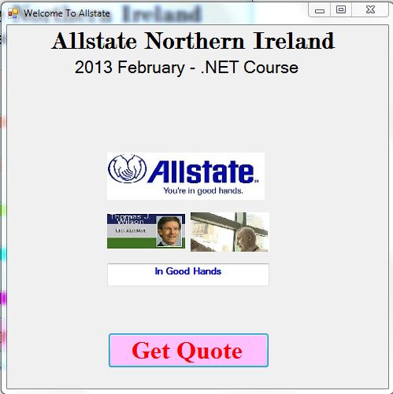
- Get A Quote Form
  - A form that will allow the user to enter their name and car age, The form will contain;
    - Label for Name
    - Textbox for Name
    - Label for Car Age
    - Textbox for Car Age
    - Button for get quote
    - List box to display the quote information
    - Button
- Functionality
  - The Get Quote button does a calculation for user quote. The calculation is based on the formula (80 – Car Age) * £10
  - The quote is displayed in the list box with an appropriate message
  - The button Enter Car Details moves the user to the next form (get a quote)

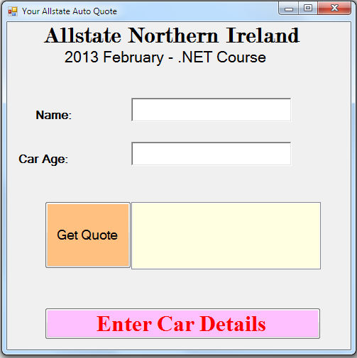

- Car Details Form
  - A form that will allow the user to enter the following information:
    - Label for Year Combo for Year
    - Label for Manufacturer Combo for Manufacturer
    - Label for Model Combo for Model
    - Label for Body Combo for Body
    - Label for CC Combo for CC
    - Label for Doors Combo for Doors
    - Button
- Functionality
  - The combo boxes must be populated with some data relevant to the purpose of the combo box.
  - The button Enter Payment Details displays a Message Box with an appropriate message that informs the user of the details they have entered on this form
  - The Message Box will have an OK button and when the Message Box is closed the code moves the user to the next form (enter payment details)

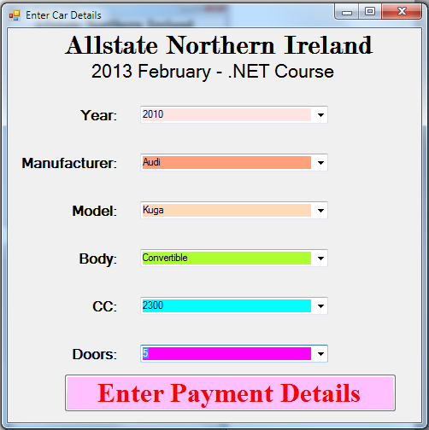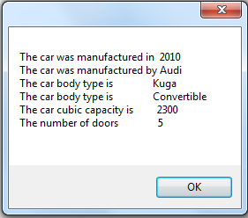

- Enter Payment Details Form
  - A form that will allow the user to enter the following information:
    - Label for Payment Method Combo for Payment Method
    - Label for Name on Card Textbox for Name on Card
    - Label for Card Number Textbox for Card Number (6 numbers)
    - Label for Expiration Date
    - Combo for Year
    - Combo for Month
    - Button
- Functionality
  - The combo boxes must be populated with some data relevant to the purpose of the combo box.
  - The button Submit Details For Validation takes the card number and subtracts the month value and the year value of the expiry date from the card number
  - The button Submit Details For Validation displays a Message Box with an appropriate message that informs the user of the details they have entered on this form
  - The Message Box will have an OK button and when the Message Box is closed the code moves the user to the first form (Welcome screen)

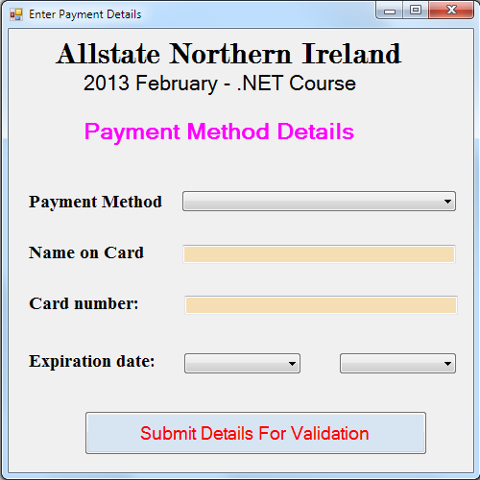
You are required to submit the following:

- The project folder (place it in the Training Folder ensuring the folder has your name included)
- Printouts of the code behind all forms

Mark Scheme:

%
Design of GUI 10
Code comments 10
Code Structure 40
Code Logic and Validity 15
Addition form using checkboxes and radio buttons 10
Additional features from within the course content taught to date 15

